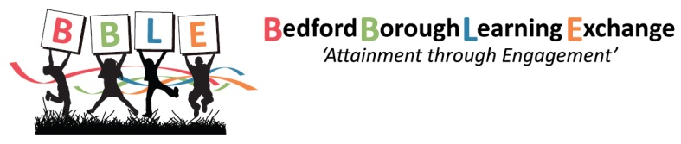

BBLE Dates 2019/20
Thursday 19th September 2019 (AGM)

Thursday 7th November 2019

Thursday 16th January 2020

Thursday 12th March 2020

Thursday 4th June 2020

END OF YEAR DINNER - Thursday 9th July

