Bedford-Copenhagen Learning Exchange

B4 Group Visit: 20th - 24th September 2015

Katrinedal Skole (0-9 Grade School)

Katrinedal Skole is situated in an affluent area on the outskirts of Copenhagen. It has 900 pupils ranging from grade 0-9 (the equivalent to our years 2-11) the majority of whom are ethnic Danes. Most of the buildings were from an older generation (the 30s) but there has been an extensive renovation inside plus the start of a new build was in evidence on the edge of the school grounds.

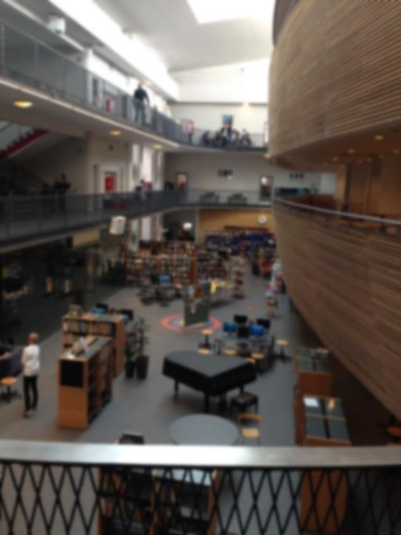
The school is a research profile school which is similar to our specialist schools in the UK. They are expected to be a beacon school within agree research areas and be available to share experiences and learning with other schools. The funding received is used to contribute to teachers’ salaries, resources and the buying in of researchers from universities (University of Aalborg). The school has been working on two main projects over the last three years; the use of technology in the classroom from grade 0 onwards and the implementation of the Advancement via Individual Determination (AVID) programme to support the less academic students to succeed and improve their opportunities within and post school (http://www.avid.org/about.ashx). Their learning is regularly disseminated to other schools and educational organisations in Copenhagen.

We were welcomed by a team of four teachers who hosted us for the two days spent in their school. They were incredibly open and honest and were proud to show us around. We were greeted, each day by a ‘second breakfast’, a lit candle and flowers on the table.

The students were confident, curious about us and had no qualms about coming up to us directly and asking us questions, in extremely eloquent English. What was evident from the get-go was the confidence and independence of all students, regardless of their grade/year group. Each class we visited had a calm and relaxed atmosphere. There were no raised voices, any level of disruption or bad behaviour. The students and teachers used the whole classroom to their advantage: students going under the desks to confer, sitting on desks and continually moving around. This was all accepted as being part of the learning process.
One of the new reforms recently bought in is that students are expected to have 45 minutes of activity a day. This could be incorporated in anyway; hence, if a student feels like they need a run around to get rid of excess energy, they can. They do not take advantage of this, from what we saw. We also saw evidence of teachers putting in ‘brain breaks’ for the children which is also counted as part of the 45 minutes.
Parental relations are extremely important for the school; this shows itself in the relationship that the student has with their main teacher and the school with the parents. Due to the affluent nature of the local of the school, the expectations of the parents and subsequent pressure can be difficult. However, the school ensures that the parents are asked to contribute at all stages in their child’s learning. They are even asked to come in to school to talk about their own work at certain times during the year.
The school regularly take students on educational visits. To take students out of school is a simple process, the only paperwork being a form to say which teachers will be out of school so that classes can be covered. Parents are not expected to give permission for their children to attend the visit and risk assessments were a new concept to the staff we spoke to. This shows the level of trust given to the teachers by all stakeholders within the school, as well as trust given to the students to be responsible for their own safety and behaviour. This was such a difference to our own system that it made many of us nervous and not sure that we would be comfortable working in this way. However this could be due to our culture of accountability rather than trust.

Learning styles

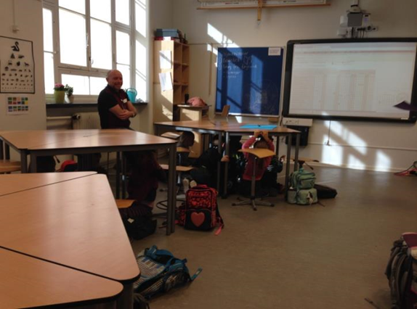
During our stay in Copenhagen we were privileged to observe a variety of lessons. Without exception, colleagues were impressed by the independent skills displayed by students in all grades; a large degree of trust was placed upon the children in giving them the freedom to plan their own time in completing tasks and activities. Typically, in the primary years, there would be a ‘choice’ of tasks for the children to work on throughout the week; there was a clear expectation that these would be completed, but the children had control over how and when they worked on each activity. New skills were typically taught at the beginning of each day or week, thus providing the input and guidance required. Computers and laptops were readily available and appeared to be used regularly as a tool throughout the curriculum. Students from grade 5 / 6 (Year 7+) tended to have their own devices which they brought from home, including smart-phones, and work was able to be ‘shared’ on the cloud between children in collaborative projects. One Grade 9 lesson observed was centred on internet safety, including the dangers of trolling. Students presented their research to the class in English; our group was astounded by the clarity, maturity and advanced presentation skills of the class who had worked independently, as well as collaboratively when interviewing one another about first-hand experiences in their use of social media.

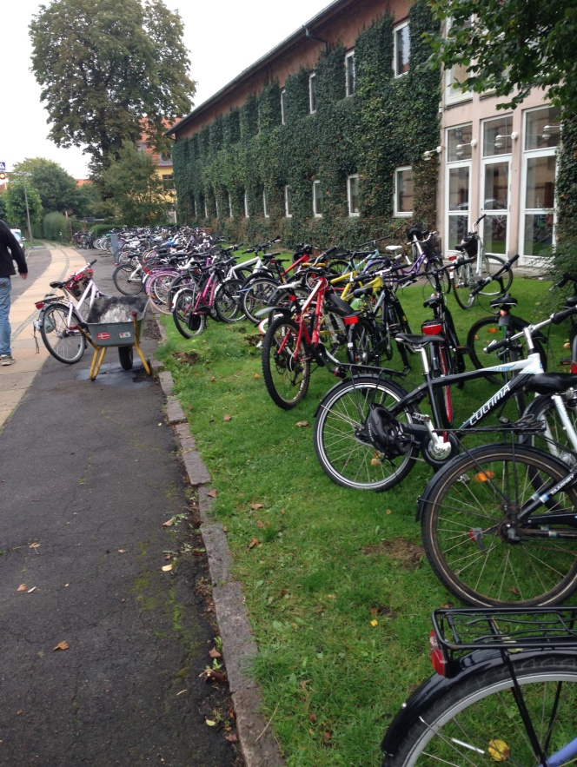
Another key observation was the calmness we felt in every class visited. There was a definite sense that children were encouraged to progress at their own pace, without being moved on to the next stage before they were ready; students were seen very much as individuals with a variety of different strengths and talents. There were opportunities for the children to work either in class, or in ‘break-out’ areas which were not under the direct supervision of the teacher. What became obvious however was that this freedom was not abused, perhaps because it was nothing unusual and merely a natural part of the learning process with which all children had grown up with since the beginning of school. One music lesson we observed began with the teacher explaining the learning goals for the lesson to the class and a ‘warm-up’ session, followed by an activity which involved groups of 4-5 children preparing a rhythm presentation which they would later show to their peers. The children worked in small groups in a variety of classrooms, again without direct supervision, but remained on task and were visited throughout the session by their teacher who provided advice and answered questions as necessary.

The overriding feeling we had every day, in every class, was that the children were fulfilled and enjoyed being in school. The atmosphere was one of a happy family, where children and adults held mutual respect for one another; this was obvious from the way adults spoke to students and vice versa. By the time students reached Grade 9 (Year 11) we had no doubt, as a group, that they had developed the skills necessary to make a success of their next stage in life and the maturity to cope well with the many new demands and challenges ahead. We all felt that there was much to be learned from the learning styles observed, particularly as the results appeared so impressive; independent and pupil led learning, a calm working environment, a focus on individual needs and an emphasis on the teacher facilitating opportunities for children in acquiring the academic and social skills they would need to lead successful lives.

Leadership Structure and Accountability

In the absence of any formal monitoring programme or any obvious paperwork relating to classroom practice, it could have been easy to assume that the relaxed learning environment and truly independent learning we witnessed happened by accident rather than design. Not so. A few key questions led us to understand that the leadership structure within the school was created to ensure the best possible provision for pupils with their learning and outcomes firmly at the centre. There are four key school leaders; headteacher, deputy headteacher, administration head and head of departments (our curriculum equivalent). Beneath this were a number of senior leaders linked to aspects of school improvement and inclusion. These staff met every 4 - 6 weeks in different formats. This led to other questions about structure, for example, did the Stage 4 team (equivalent to our Year 6) work together because they liked each other and shared common goals? No, they were put together because they offered a range of skills and could teach a broad range of the curriculum. It was also not uncommon for senior leaders to teach across grades with two members of staff teaching in Grade 1 (Y3) and 7 (Y9), or Grade 2 (Y4) and 8 (Y10) to ensure any gaps in curriculum were covered.

Discussions with the head and deputy raised the same dilemmas we face; more emphasis tended to be placed on pupils’ knowledge as it was measurable, than on the more qualitative aspects of learning such as skills and competencies. Until recently grades have not been awarded to pupils before Grade 7 (Y9), but it is clear that our accountability system is on their horizon as that very afternoon the head and deputy were meeting with a company called “My Education” who were showing them a tracking system they could buy in to. Therein lies a dilemma: it is clear they need more accountability for pupils’ progress to avoid individual and group underachievement, but how to gain this without creating the pass or fail culture pupils can so often find themselves in within our system? One Grade 7 pupil summed this up perfectly when she said that suddenly there was a best and worst in the class and she could not see how this helped either of these pupils. This ties in with the Sutton Trust research that pupils improve much more rapidly with constructive and timely feedback rather than percentages or grades. We debated this subject soundly amongst our group.
Staff wellbeing was very high on their agenda; a lesson observation that might have gone wrong would be approached as finding out why and what was going on in that member of staff’s life that might be making things more challenging for them. Support would then be offered. This is not far from the practice in our best schools where accountability is not compliance, rather a professional contract between senior leaders and staff to deliver their best and be in charge of their own self-improvement and professional development within the support of their organisation. I look forward to furthering discussions with our colleagues when they visit our schools, so we can see how best to combine the relaxed atmosphere and positive learning environments with our system of more formal accountability for both staff and pupils.

Finally

Our group came away from our experience with a mantra that is still evident in the few weeks we have been back in England. ‘What Would the Danes Do?’ or WWDD? We have all taken this on board whereby, if we have any doubts, we take a step back, take a moment to think about the Danish attitude and readdress our own approach. It has already worked!


Richard Knowles, Livingstone Primary School
Vanessa Wilson, Queens Park Academy
Jenni Gayter, Newnham Middle School
Caroline Piotrowski, Biddenham International School
& Sports College
Lisa Ryder, Fellowship Programme

September 2015

