Step into Leadership – a case study
The Bedford Borough Learning Exchange (BBLE) sponsored the Step into Leadership project which was led by Biddenham International School together with Great Denham Primary School. The BBLE is a forum for those in leadership from all the educational organisations within Bedford Borough to meet, share and learn. Members include all the state schools, the private schools, the college, university and even the prison education service! The BBLE is fully inclusive!
Bedford Borough has for many years, been an ethnically diverse area with the Italian and Polish communities arriving after the war, to the growing number of Asian and Caribbean/African families and now includes those from Eastern Europe. The schools within the urban area of Bedford are no strangers to dealing with English as a Second Language and to having to adapt to cultural challenges from all pupils. However, this diversity, which in the current 0 – 4 year age group, 51% are from BME groups, is not reflected in the leadership in our schools.
Mike Berrill, Executive Principal of the Biddenham Campus Trust and a founding member of the BBLE together with Lisa Ryder, a programme manager with experience in setting up and managing different projects decided to address this issue. Neither are from a BME group so didn’t feel we could address BME issues that may arise but we could offer an interactive, highly practical workshop based programme constructed around the six Hay McBer Leadership dimensions. Our aim was to empower a group of BME colleagues with the confidence, skills and aspirations to become future leaders and inspiring role models.
The first hurdle was getting participants to sign up for the programme. Potential participants felt that they were being singled out and it wasn’t comfortable for them. Their school colleagues also wanted to know why they couldn’t do it! To get round this, we approached the headteachers and leaders directly, through the BBLE, to ask if they would recommend BME colleagues from their schools to be part of the programme, looking specifically at those who had potential leadership qualities.
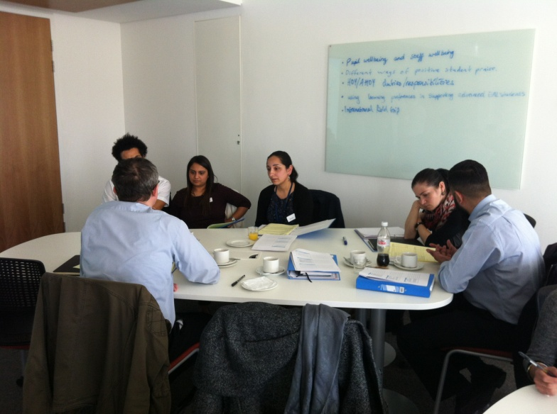
In January 2015, we held a launch for the Step into Leadership programme with eighteen participants attending with their allocated mentor. We were supported by the Chief Education Officer, Colin Foster and by the University of Bedfordshire who gave participants free access to the university library and the venue for free. Grassroots plc, a leading provider of employee engagement solutions, offered access to the PoD, an online, interactive development site. Plus, we also asked participants to take part in the Embracing Diversity programme; an online diversity learning programme of study.
The programme ran over six, four hour sessions from January to July with each session focusing on one of the dimensions. Running alongside this, each participant was asked to choose a project, focusing on the values and needs of their own organisation whether that was a small scale change within a team or across a whole department. As the dimensions unfolded, so the projects could evolve and develop with some tangible outcomes at the end of the Step into Leadership programme.
In addition to the dimensions, local, inspirational speakers were asked to come and talk to the participants about their experiences and how they reached their own goals.

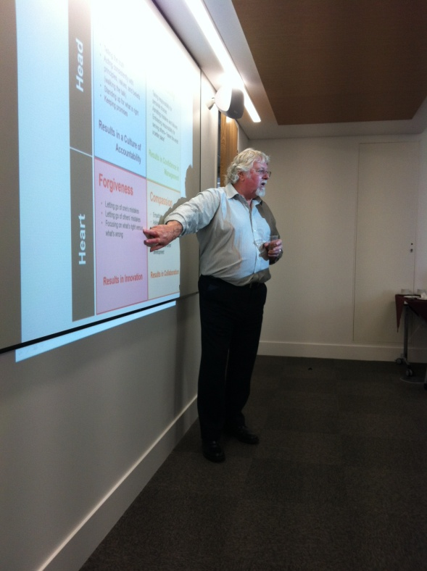
The programme was given a structure in that at each session there was a review of the previous dimension, the new dimension was discussed and dissected followed by and introduction of the next one. However, it was flexible enough that we were able to make changes and adapt as necessary. In addition to this, each participant was asked to consider a 360 diagnostic tool plus a number of competencies relating to each dimension. This was all emphasised by the constant reminder of the Ebbinghaus Curve of Forgetting!
At each session, the emphasis was very much on using their own personal and professional experiences to develop each dimension. Everyone had an opportunity to discuss the outcomes, to reflect on their current practice and to work together to develop different approaches.
What was evident from the start was the growing bond within the group. Some of the participants already knew each other but the majority didn’t. At the beginning of the programme, a seating plan was employed to ensure that, when working in pairs or groups, they were able to get to know someone new. This meant that by the second session, the feeling of a fully committed working partnership was showing through. The turning point was during session three, Visioning. The request was for each participant, using one slide only, to present an overview of their project with progress to date within 5 minutes. Each of the presentations were then discussed and critiqued by the whole group. The impact of each presentation plus the support and enthusiasm from each participant was akin to a religious experience.
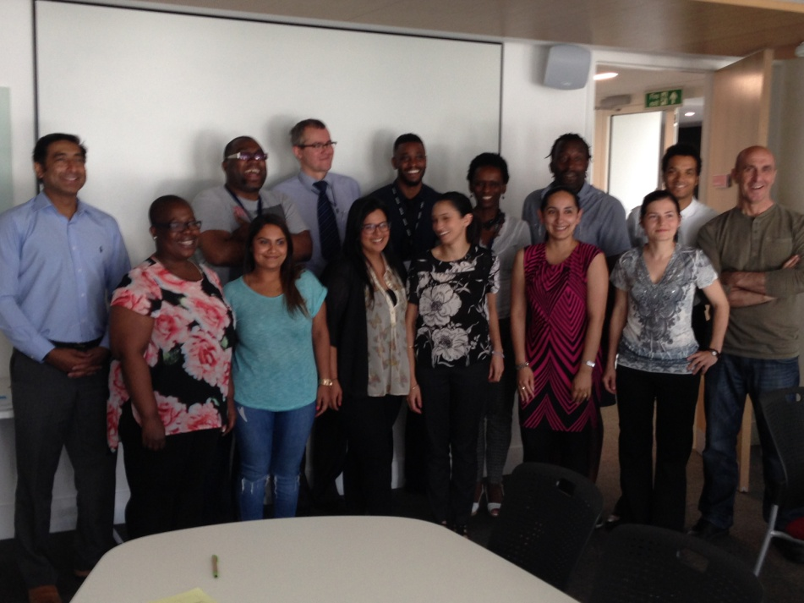
Each school/organisation was asked to allocate a mentor for each participant. The role of the mentor was to act as a critical friend. With hindsight, there should have been more structure/guidance given to the mentors at the beginning of the programme and then further emphasised through more frequent mentor meetings.
The programme was only the guide; it was the participants themselves that drove it and in doing so, built up their own confidence and confirmed their own skills base in developing their roles as leaders within our educational communities. At the end of the programme, a final celebration event was held at the University of Bedfordshire. This was attended by their headteachers, mentors, colleagues and families plus representatives from the Local Authority and National College for Teaching and Leadership. The participants were asked to present on their learning and on how the programme has changed their approach to leadership. They created an inspirational video which is summed up as follows:
‘This experience was one of a kind. This is the first time I have ever been addressed with a focus on my culture/ethnicity in a professional setting. Meeting the special guests, was a privilege and the group, well, you know they all helped me to realise that our struggles are common no matter your ethnicity, culture or gender. Now we have the tools and support of each other to change and reshape those struggles by recognising the barriers... and smashing through them.’ Jason Gay
The fact that we had a group of mixed minority ethnic teachers did actually make a difference. It meant greater cohesion for them as a whole and a realisation that ethnicity didn’t really matter. If it had been a general group of teachers, this wouldn’t have been identified. It was the group itself that became powerful.
Two of the participants have already been successful in getting Head of Department roles with others applying or having the confidence to make changes within their own departments. Going forward, we are keen to run another programme in the summer term of 2016. What has encouraged us is that the participants are keen to be involved in the delivery of the programme and encouraging other colleagues to take part!
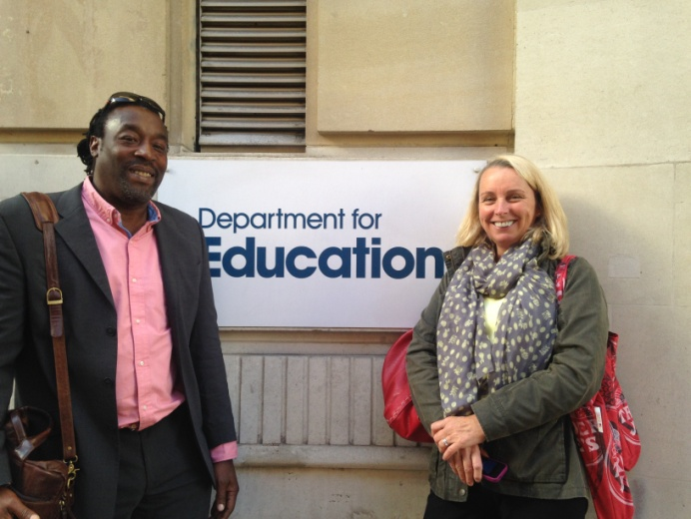
Mike Berrill and Lisa Ryder
August 2015

Postscript 1 October 2015
Tony Boatswain and Lisa Ryder were invited to the Department for Education to present the programme and the outcomes to new project leads and members of DfE staff.

